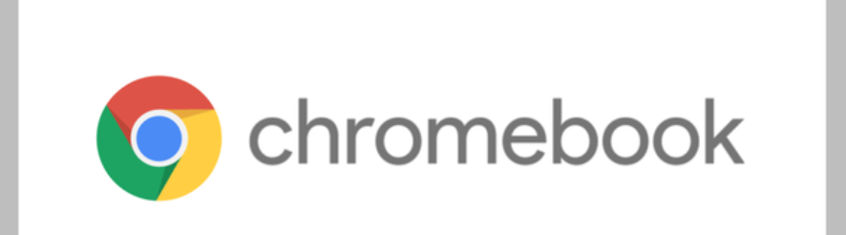

**Google Chrome 96 Release Enables Camera as Document Scanner**

Developing with natural elegance, Chrome’s new core and devices have been affordable and comparable. Google has advanced its computer fleet even more, Chrome 96 has now endowed the camera with new capabilities→document scanner mode:

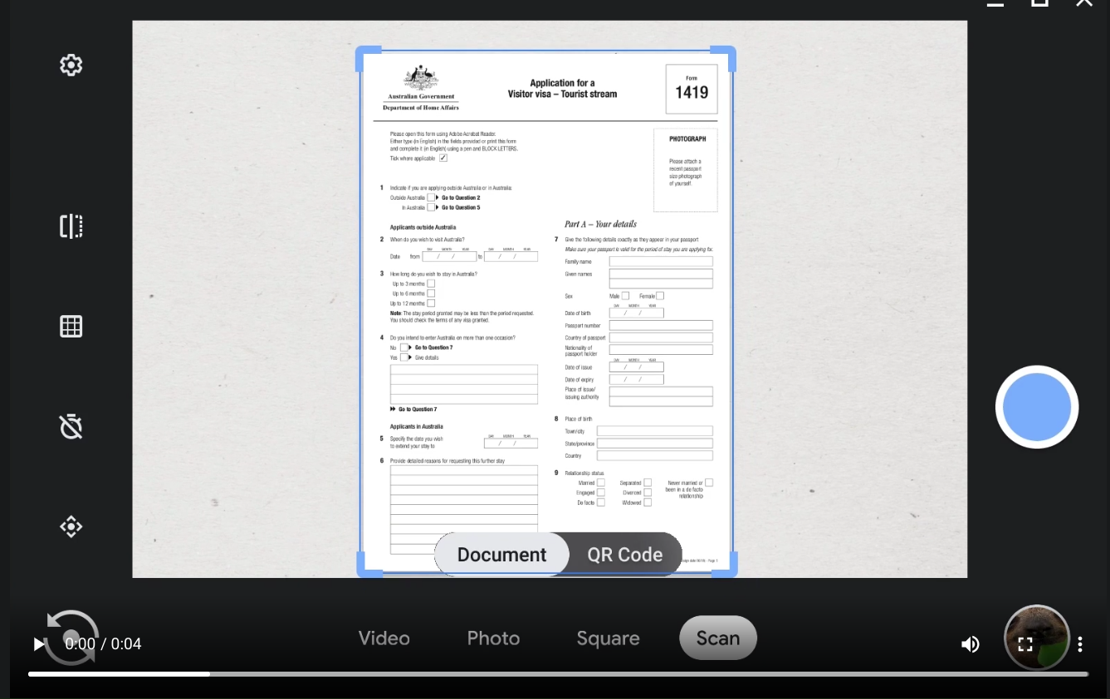

An all new feature set for laptops debuts on the very innovative Google Chromebook.

According to [The Keyword by Google](https://blog.google/products/chromebooks/new-camera-updates/), you can now use your Chromebook’s built-in camera to scan a file and generate it into a PDF or JPEG file.

End users can use both the front and back facing camera to scan with Chromebook.

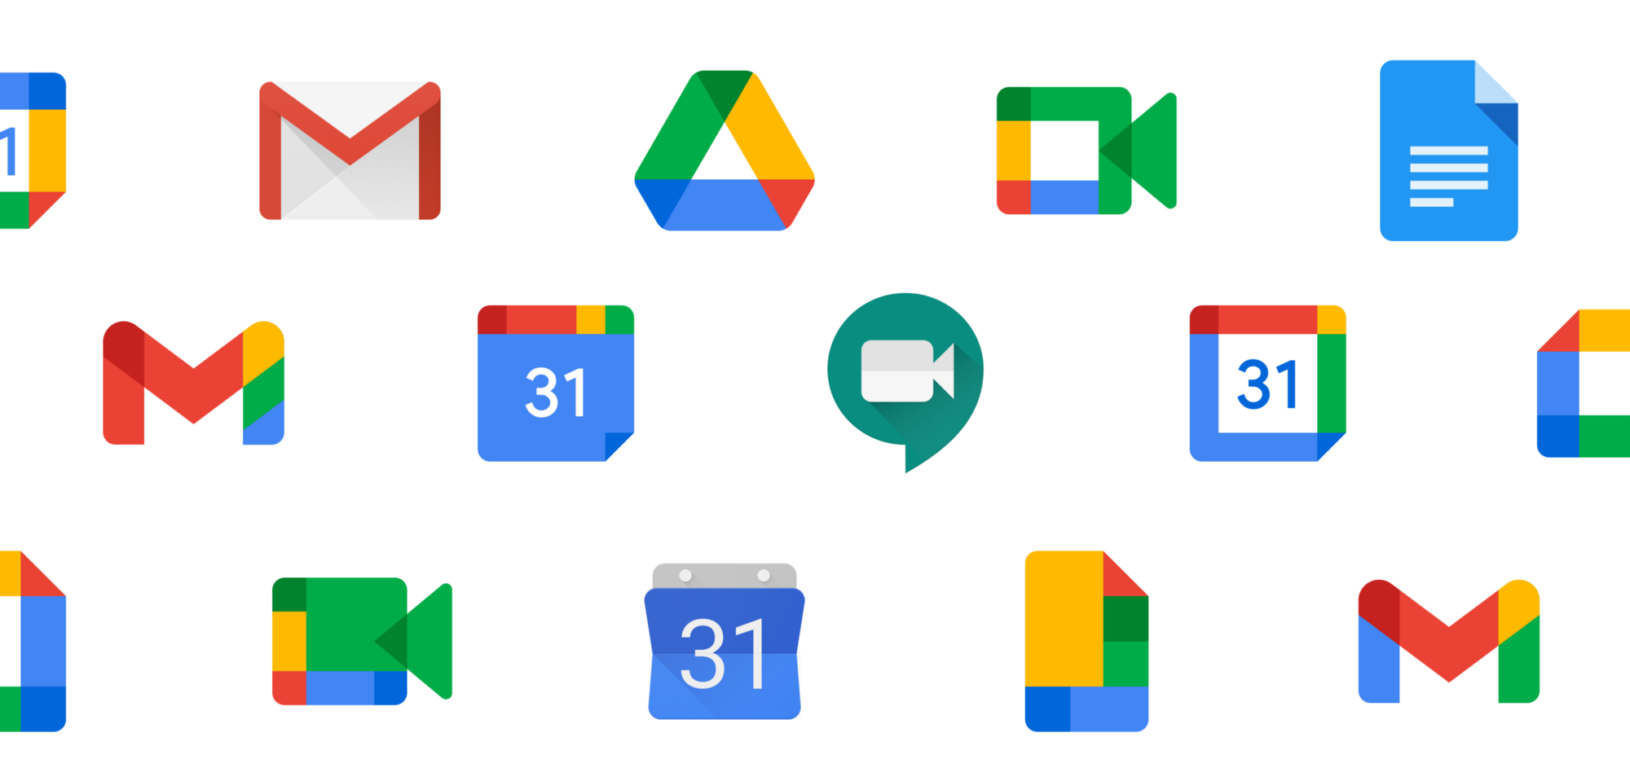

Scanning with the Chromebook camera is very easy to start using: Open the Camera app and select “Scan” mode.

When holding the document chosen to be scanned, the perimeter of the document will be detected automatically by the camera.

Upon scan completion, end users can share the new scanned file through Gmail, to social media or to nearby Android phones or Chromebooks using the exclusive Google Nearby Share feature.

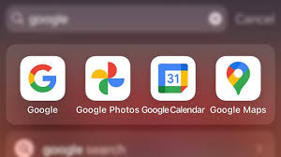

In the case end users use external cameras with the Chromebook, there is a Pan-Tilt-Zoom feature that enables more control over what the camera captures. End users can crop and angle the camera view exactly as desired.

It’s a very easy application to adapt to: when the external camera is plugged in and configured, simply open the Camera app to adjust the angle to be captured.

As a reminder, Chromebook’s camera application has had the following feature set:

* ***Video mode***
* ***Self timer***
* ***QR Code:*** use the front or back facing camera to scan a QR code
* ***Save for later***

According to Jon Mundy with Trusted Reviews, “...in early 2022, you’ll be able to create your own GIFs in the Camera app. It seems you’ll simply be able to record a five second video snippet and have it turned into a shareable GIF.”

Google is also beta testing a feature that integrates the Camera app with Google Assistant, thereby enabling end users to control the Chromebook’s camera with your voice. Simple voice commands such as “take a picture” or “record a video” and the app will capture.

Google is rumored to be constructing its own chips for future Chromebooks. Reportedly, the custom Tensor silicon, which integrated into the Pixel 6 and Pixel 6 Pro, plans to make a debut in a Chrome OS device from 2023.

The Chrome OS 96 added a toggle for each app's notification settings, end users must navigate to Settings→Apps and flip a switch for the applications notification toggle.

Chrome OS 96 allows for end users to host links open in-app or in the Chrome browser. To configure this navigate to the "Opening supported links" section under "Manage your apps."

Finally in road map updates, the Wallpaper app has a dedicated icon, being no longer relegated to the desktop's right-click menu.

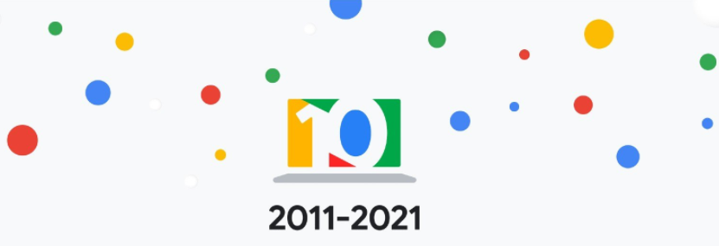

Tags: google, goolechrome, googleos96, chromeos96, OS96, cameraapp, googlecamera, googlecamerapp, scan, scanning, newfeature, pdf, jpeg, googlepdf, googlejpeg, chromebook, chromebookupdate, chromebookos96, chromebook10years

References: [Do even more with your Chromebook camera](https://blog.google/products/chromebooks/new-camera-updates/), [Google runs through new Chromebook camera tricks](https://www.trustedreviews.com/news/google-runs-through-new-chromebook-camera-tricks-4188426), [Chrome OS update turns Chromebooks into scanners](https://arstechnica.com/gadgets/2021/12/chrome-os-update-turns-chromebooks-into-scanners/)